
Running Phi-4 through Ollama

Evan Gall
CCNP

Purpose:
Be able to run an U.S. AI engine through docker with Ollama. This lab covers topics such as AI engines, how to use AI model runners like Ollama, and how to use containerization platforms such as Docker.
Background Info and Concepts
AI engines
An AI engine is a software system that processes information and generates responses, predictions, or other outputs based on its training and programming. AI engines can answer questions, write text, generate images, analyze data, and help users solve problems. AI can help workers and students efficiently complete their work.
Many modern AI engines use large language models (LLMs), which are trained on large amounts of text and other data to recognize patterns and generate human-like responses. Examples include GPT, Claude, and Phi-4. Depending on the model, AI engines can run through cloud services over the internet or locally on a computer. In this lab, we ran Phi-4 locally on the computer.
AI engines are useful for education, research, programming, automation, and many other applications. However, answers from AI must be taken with a grain of salt.
AI Model Runners
AI model runners are software tools that allow users to load artificial intelligence models on a computer or server. They manage the process of running a model so that users can interact with AI without needing to build the entire system themselves. Some model runners, such as Ollama, allow users to download and run LLMs locally like how we did in this lab. Running models locally can improve privacy and reduce reliance on internet-based AI services, although performance depends on hardware.
Containerization Platforms
Containerization platforms are software tools that package applications into isolated environments called containers. These containers help applications run consistently across different computers and reduce user’s manual configurations. Docker is a popular containerization platform and the one that we used in this lab. Docker allows users to create, manage, and run containers. Docker can be used to install AI model runners in organized environments, simplifying installation, configuration, and management.
How AI model runners and containerization programs work together
AI model runners and containerization platforms serve different but complementary purposes. An AI model runner executes the AI model, while a containerization platform provides an environment in which the runner and its supporting software can operate. For example, Ollama can run an AI model inside a Docker container, allowing users to manage the software through Docker while interacting with the AI model through Ollama. Docker makes it easier to run Ollama by keeping its software and files in a separate environment from Windows.
Lab Summary
I was able to run Phi-4 through Ollama inside the docker terminal. I did this by downloading both Docker and Ollama, pulling Ollama through docker. Then through the docker terminal using commands ollama pull phi4 to install phi4 locally, then using ollama run phi4 to run the AI.
Network Diagram
IPs: PC receives addressing from DHCP
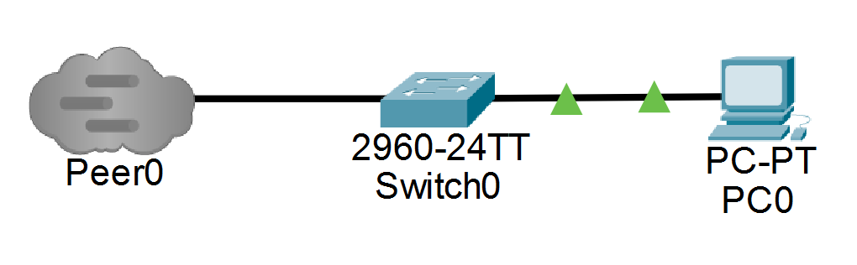
Configurations
Downloaded Ollama through: https://ollama.com/download/windows
Downloaded Docker through: https://www.docker.com/products/docker-desktop/
Pulled Ollama through Docker.
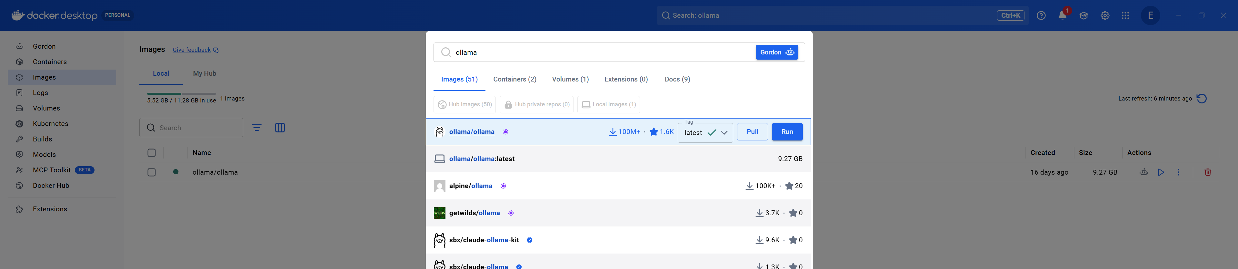

Commands
After pulling Ollama through docker. Open up docker terminal and run the command: ollama pull phi4 to install Phi-4 locally.
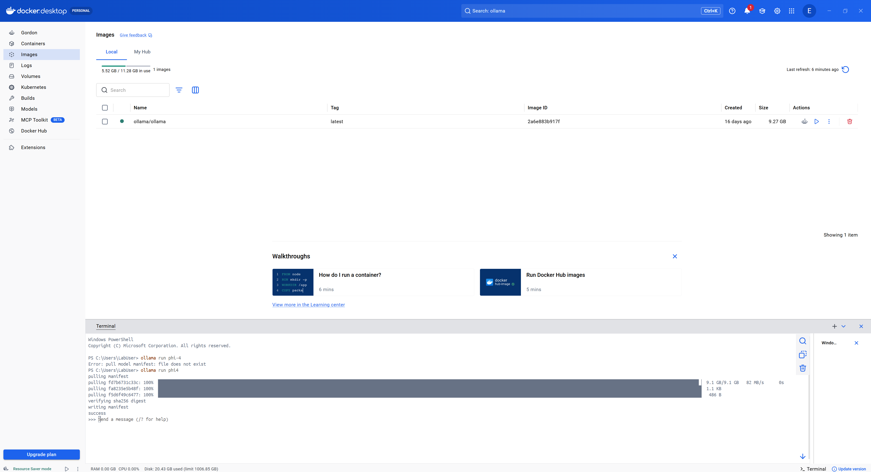
And to run Phi-4 after installing: ollama run phi4
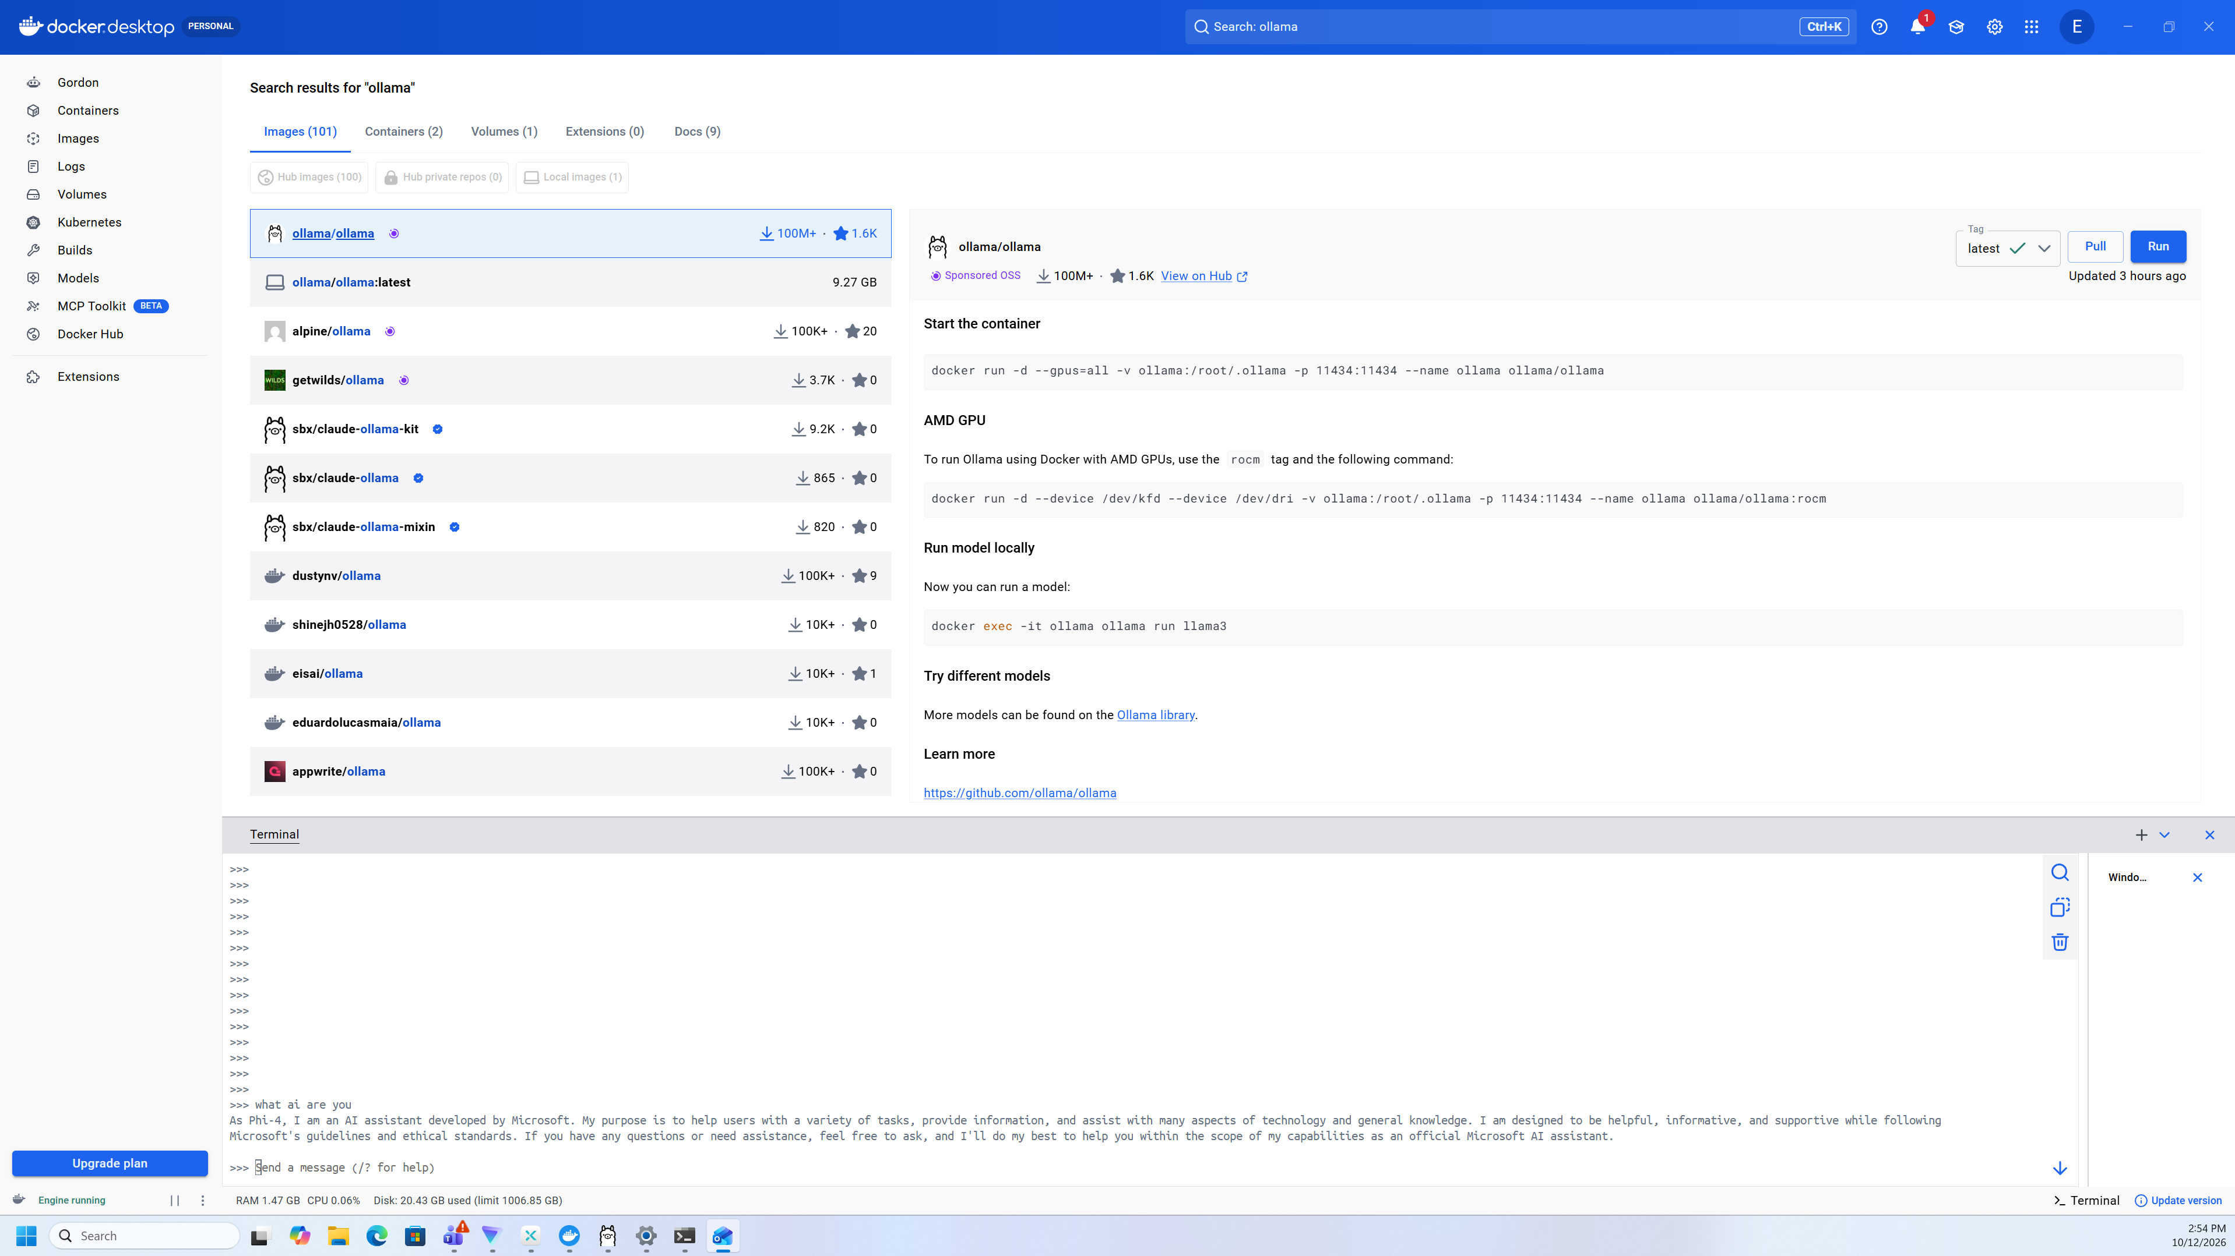

Problems
We had trouble figuring out which command to run and pull through the docker terminal to run the Phi-4 AI (which we already installed before). For this, we simply prompted ChatGPT to find the command, which gave us: ollama pull phi4, and ollama run phi4. With this command we are able to run phi-4 anytime through powershell or the docker terminal
We also had trouble finding out how to run the AI through docker. For this problem a classmate helped us find the terminal on the bottom right of Docker, and seeing how it was basically just powershell, we then went off that knowledge and were able to run Phi-4 through Docker smoothly.
Conclusion:
Able to prompt Phi-4 through the Docker Terminal.

